Programme
Wolfgang Amadeus Mozart (1756-1791)
Fantasy in C Minor, KV475

Frederick Chopin (1810-1849)
Fantasy in F Minor, Op.49

Johann Sebastian Bach (1685-1750)
Chaconne Transcribed by Ferruccio Busoni (1866-1924)

Programme Notes
W. A. Mozart: Fantasy in C Minor, KV475
The Fantasy in C minor, K. 475, was completed some seven months after the Piano Sonata in C minor K.457. Mozart recorded the date of completion as May 20, 1785 in his private catalogue of works. In the same year, the piece was published in Vienna together with the sonata under the collective designation "Op. 11." In this version, the Fantasia serves as an introduction to the sonata. Opinions have differed whether Mozart intended the two to be performed together. Although they were published as the same opus, Mozart sometimes performed the pieces separately. In today’s concerts, the Fantasy has been treated as a formal individual piece. Its abundant materials and innovative form make its importance not less than the C Minor Sonata’s.

F. Chopin: Fantasy in F Minor, Op.49
Although Chopin’s critical standing as a composer grew steadily during the 18 months he spent in Paris from October 1839 to June 1841, it was in reality a far from productive period. It seems that around this time he engaged in a major re-examination of his artistic aims, and it was only when he returned to Nohant for the summer of 1841 that the results became evident. By the end of the summer he had completed the Prelude op.45, the Nocturnes op.48, and two major works, the ABallade op.47 and this F minor Fantasy op.49. In spite of using the term “Fantasy” as the title of this piece, Chopin did not make it in the Baroque sense, as an improvisatory or freeform work. For him, it was a highly structured, single-movement composition, based on, but expanding, the classical sonata form.

J. S. Bach: Chaconne (Transcribed by F. Busoni)
The Partita in D minor for solo violin by J. S. Bach was written during the period 1717–1723. The partita is a five-movement piece; however, the final movement, Chaconne, surpasses the duration of the previous four movements combined. Along with its disproportional relationship to the rest of the suite, it merits the emphasis given it by musicians and composers alike. The theme, presented in the first four measures in typical chaconne rhythm with a chord progression based on the repeated bass note pattern “D, D, C-Sharp, D, B-Flat, G, A, D” begets the rest of the movement in a series of variations. The overall form is tripartite, the middle section of which is in major mode. This piece is a pinnacle of the violin solo repertoire. Although it was composed almost 300 years ago, it is still one of the most technically and musically demanding pieces. Since Bach's time, several different transcriptions of the piece have been made for other instruments, particularly for the piano by F. Busoni and for the piano left-hand by J. Brahms.
In 1892, Busoni transcribed this great piece and dedicated it to the celebrated pianist, Eugen d’Albert. However, reproached by his dedicatee for “tampering” with this revered work, Busoni replied, “I start from the impression that Bach’s conception of the work goes far beyond the limits and means of the violin, so that the instrument he specifies for performance is not adequate.” Indeed, Bach has left us only the “bare bones”— the notes themselves with no instructions, explanations, or directions for tempi and dynamics for his complex, polyphonic masterpiece. Busoni applied the resources of the modern grand piano—its volume, range, and sustaining power—to augment Bach’s contrapuntal scoring for violin solo.
Biography
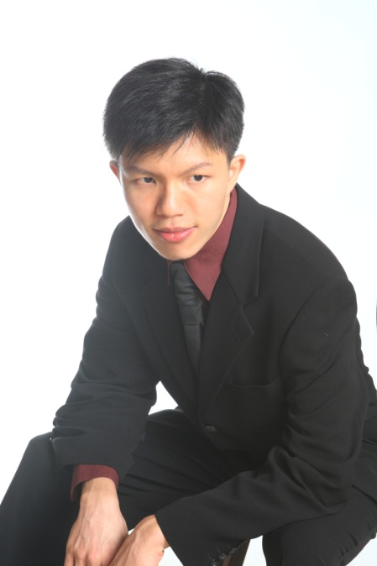
Jie-Fei Jiang has just completed a BA Degree in Music at Taipei National University of Arts and successfully acquired an offer for MMus Performance from University of Southampton and its 60th Anniversary Scholarship.
During the ten years before coming to Southampton, Jie-Fei Jiang had received instruction from Professor Alexander Sung, and had learned to play a large number of piano works. Under well-rounded training, Jie-Fei Jiang held his first piano recital in his second year of high school in his hometown, successfully played such classic pieces as Beethoven’s Sonata and Chopin’s Scherzo. In the next year, Jie-Fei Jiang held his graduation recital in Taipei, the programme in which included such hard and huge pieces as Liszt’ Transcendental Etude and Schumann’ Carnaval.
To pursue further improvement, Jie-Fei Jiang started to specialize in certain genre of programme in recent years. In 2010’s recital, he played a whole set of Chopin’s 24 Preludes and 4 Ballades; in 2011, he played four great composers’ variations in one recital, namely Mozart, Beethoven, Mendelssohn, and Schumann. Just last year, he completed a recital with four sonatas, including Mozart’s, Schubert’s, Chopin’s, and Prokofiev’s.
Now Jie-Fei Jiang is studying piano performance under Professor David Owen Norris and Professor Veronika Ilinskaya in University of Southampton.




Chaconne and Fantasies

Monday 28 January 2013, 13:00
Turner Sims Concert Hall


Jie-Fei Jiang
piano



